4/27/2016

Angel Solis

5000220181

Simple CPU

CPE 300, Spring 2016

This project was to build a simple cpu using behavioral Verilog. The processor must be able to implement the given assembly commands given in binary.

The control unit is comprised of a two bit synchronous counter and case statements. The counter keeps track of the current cycle for each instruction. The counter is reset at the completion of the instruction. Most instructions require 2 cycles with only LDM and STM requiring 3 cycles. Each cycle contains cases for each of the required instructions.

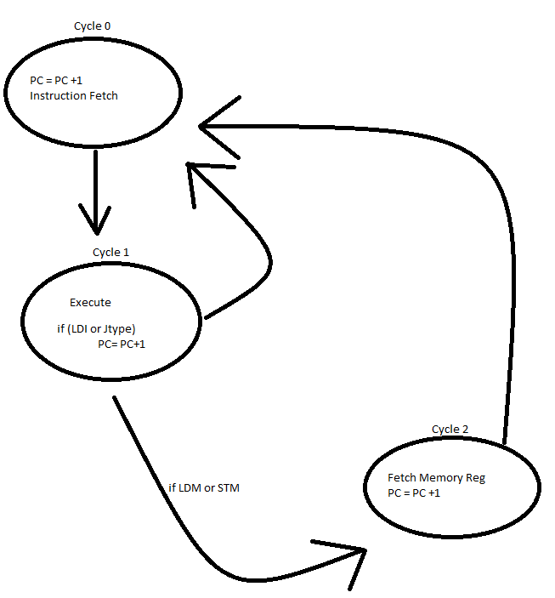

*FSM Cycles*

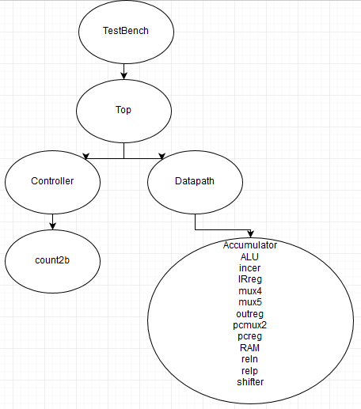

*Verilog Hierarchy*

The image above shows the hierarchy of the Verilog files. The testbench the top most file as it provides the clock to every other file. The testbench then calls the main which in turn connects the controller and the datapath together. The controller only uses the count module to keep track of the current cycle, it uses the current instruction supplied by the datapath to assert the needed control signals based on the current cycle. The datapath connects all the other modules together like the picture below.

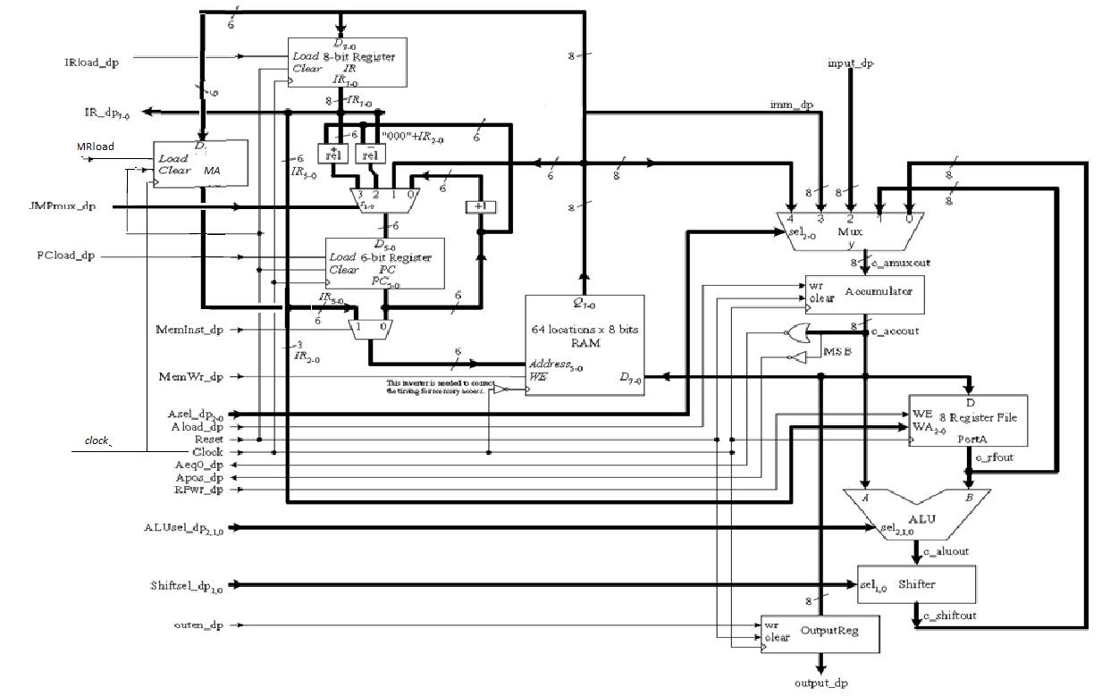

The table below shows how the control signals change based on the cycle and the current instruction. It also shows the encoded ALU and Shifter values. The brackets indicate that the output is adaptable depending on a status signal from the datapath.



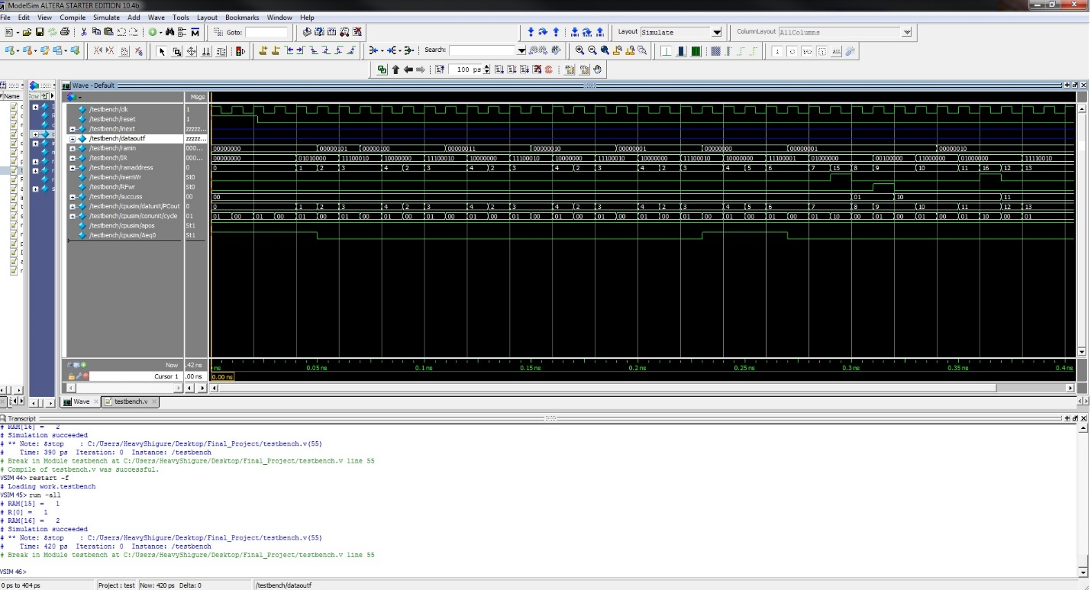

*Waveform output*

The wave form above is the output from the testbench when running the provided assembly instructions. The wave from includes the PC, the current instruction, the current cycle, the memory write enable signal, the current address being written to, and the contents of input wire to the memory. These signals were chosen to show both the jumping instructions, and the write instructions.

The testbench starts out by forcing reset to ensure that all the registers start in a known state. Then the clock signal begins to invert every 5 time units. Then whenever the Register File write signal experiences a negative edge it checks to see if the correct register was selected and if the correct value was on the input wire. If both of the conditions are met then a separate register is incremented. At the same time that it checks the Register File it also checks the memory write signal. When the memory write experiences a negative edge it checks the selection address and the input wires for the expected values. And then increments the separate register by one. If at the end of the simulation the register contains the number three then all three expected writes occurred with the correct addresses and input data. The testbench instructions and an explanation can be found after the Verilog files.

Contents of RAM after testbench ran

E:\school\CPE300\Final_Project\Outputs\reg memsmall.png

Register File contents after testbench

Time Analysis

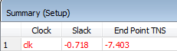

The timequest analysis showed that the clock time of 1ns was too fast by .718. This means that our cycle time should be 1.72ns which is 581.73 MHz.

For performance analysis T= IC x CPI x Cycle can be used.

$$T= IC X CPI X τ$$

$$IC=9 CPI=\frac{56}{27}=2.0741 τ=1.72ns$$

$$T= 9 X \left[\frac{56}{27}\right]X 1.72ns=9 X 3.5674074$$

$$T= 32.10667ns \\ P=\frac{1}{T}=\frac{1}{32.10667}=31.1146 MHz$$

The instructions set holds all the instructions needed for basic assembly programs.

module testbench ();

reg clk;

reg reset;

wire [7:0] inext,dataoutf,ramin,IR;

wire [5:0] ramaddress;

wire memWr,RFwr;

reg [1:0]succuss;

top cpusim(clk,reset,inext,dataoutf,ramin,IR,ramaddress,memWr,RFwr);

// initialize test

initial

begin

succuss <= 2'b00;

reset <= 1; # 22; reset <= 0;

end

always

begin

clk <= 1;

# 5;

clk <= 0;

# 5; // clock duration

end

// check results

always @ (negedge RFwr)

begin

if (IR[2:0] == 3'b000&&ramin == 8'b00000001)

begin

succuss <= succuss + 1'b1;

$display ("R[",IR[2:0],"] = ", ramin);

end

end

always @ (negedge memWr)

begin

if (ramaddress == 6'b001111&&ramin == 8'b00000001)

begin

succuss <= succuss + 1'b1;

$display ("RAM[",ramaddress,"] = ", ramin);

end

else if (ramaddress == 6'b010000&&ramin == 8'b00000010)

begin

succuss <= succuss + 1'b1;

$display ("RAM[",ramaddress,"] = ", ramin);

end

end

always @(\*)

if (succuss == 2'b11)

begin

$display ("Simulation succeeded");

#50

$stop;

end

endmodule

module top(

input clk,

input reset,

input [7:0] inext,

output [7:0] dataoutf,ramin,IR,

output [5:0] ramaddress,

output memWr,RFwr

);

wire [7:0] dataout;//IR,

wire Aeq0,apos,IRload,PCload,MemInst,MRload,Aload,reset1,outen;//,RFwr,memWr

wire [1:0] JMPmux,Shftsel;

wire [2:0] Asel,ALUsel;

assign dataoutf = dataout;

controler conunit(clk,IR,Aeq0,apos,dataout,IRload,JMPmux,PCload,MemInst,

MRload,memWr,Asel,Aload,reset1,RFwr,ALUsel,Shftsel,outen);

datapath datunit(clk,IRload,JMPmux,PCload,MemInst,MRload,memWr,Asel,Aload,

reset,RFwr,ALUsel,Shftsel,outen,inext,IR,Aeq0,apos,dataout,ramin,ramaddress);

endmodule

module datapath (

input clk,

input IRload,

input [1:0] JMPmux,

input PCload,MemInst,MRload,memWr,

input [2:0] Asel,

input Aload,reset,RFwr,

input [2:0]ALUsel,

input [1:0] Shftsel,

input outen,

input [7:0] inext,

output [7:0] IR,

output Aeq0,apos,

output [7:0]dataout, //output reg thing);

output [7:0] ramin,

output [5:0] ramaddress

);

wire [7:0] memout,irout,MR2ram,Accin,Accout,shftout,rfout,aluout,regout;

wire [5:0] PCplus1,relnout,relpout,PCout,PCin,RAMaddr;

IRreg insreg(memout,IRload,reset,clk,irout);

IRreg MAreg(memout,MRload,reset,clk,MR2ram);

reln ad(PCout,irout [2:0],relnout);

relp su(PCout,irout [2:0],relpout);

incer plus1(PCout,PCplus1);

mux4 pcmuxin(PCplus1, memout[5:0], relnout,relpout,JMPmux,PCin );

pcreg pc(PCin,PCload,reset,clk,PCout);

pcmux2 pcmuxout(PCout,MR2ram[5:0],MemInst,RAMaddr);

RAM datainst(Accout,RAMaddr,memWr,clk,memout);

regifile regies(Accout,RFwr,irout[2:0],clk,rfout);

mux5 accmux(shftout,rfout,inext,memout,memout,Asel,Accin); //picture shows two inputs from memout

accumulator accu(Accin,Aload,reset,clk,Accout);

assign Aeq0 = ~|Accout;

assign apos = ~ Accout [7];

assign IR = irout;

assign dataout = regout;

assign ramaddress = RAMaddr;

assign ramin = Accout;

alu alumod(Accout,rfout,ALUsel,aluout);

shifter shiftmod(aluout,Shftsel,shftout);

outreg outer(Accout,outen,reset,clk,regout);

endmodule

module controler (

input clk,

input [7:0] IR,

input Aeq0,apos,

input [7:0]dataout,

output IRload,

output [1:0] JMPmux,

output PCload,MemInst,MRload,memWr,

output [2:0] Asel,

output Aload,reset,RFwr,

output [2:0]ALUsel,

output [1:0] Shftsel,

output outen

);

reg [18:0] controls;

assign {IRload,JMPmux,PCload,MemInst,MRload,memWr,Asel,Aload,reset,RFwr,ALUsel,Shftsel,outen} = controls;

reg resetcount,stop;

wire [1:0] cycle;

initial

begin

stop <=0;

resetcount <=0;

end

count2b counter(clk,resetcount,stop,cycle);

always @ (\*)

begin

case (cycle)

2'b00 :

begin

controls <= 19'b1001000xxx000xxxxx0;

resetcount <=0;

end

2'b01 : //2 byte instructions must update pc

begin

casex (IR)

8'b00010xxx: //LDA

begin

controls <= 19'b0xx0000001100xxxxx0;

resetcount <=1;

end

8'b00100xxx: //STA

begin

controls <= 19'b0xx0000xxx001xxxxx0;

resetcount <=1;

end

8'b00110000: //LDM0

begin

controls <= 19'b0xx0010xxx000xxxxx0;

resetcount <=0;

end

8'b01000000: //STM0

begin

controls <= 19'b0xx0010xxx000xxxxx0;

resetcount <=0;

end

8'b01010000: //LDI

begin

controls <= 19'b0001000100100xxxxx0;

resetcount <=1;

end

// uses alu

8'b10100xxx: //AND

begin

controls <= 19'b0xx0000000100001000;

resetcount <=1;

end

8'b10110xxx: //OR

begin

controls <= 19'b0xx0000000100010000;

resetcount <=1;

end

8'b11000xxx: //ADD

begin

controls <= 19'b0xx0000000100011000;

resetcount <=1;

end

8'b11010xxx: //SUB

begin

controls <= 19'b0xx0000000100100000;

resetcount <=1;

end

8'b11100000: //NOT

begin

controls <= 19'b0xx0000000100101000;

resetcount <=1;

end

8'b11100001: //INC

begin

controls <= 19'b0xx0000000100110000;

resetcount <=1;

end

8'b11100010: //DEC

begin

controls <= 19'b0xx0000000100111000;

resetcount <=1;

end

8'b11100011: //SHFL

begin

controls <= 19'b0xx0000000100000010;

resetcount <=1;

end

8'b11100100: //SHFR

begin

controls <= 19'b0xx0000000100000100;

resetcount <=1;

end

8'b11100101: //ROTR

begin

controls <= 19'b0xx0000000100000110;

resetcount <=1;

end

//j instructions

8'b01100000: //JMP

begin

controls <= 19'b0011000xxx000xxxxx0;

resetcount <=1;

end

8'b0110xxxx: //JMPR

begin

if (IR[3])

controls <= 19'b0101000xxx000xxxxx0;

else

begin

controls <= 19'b0111000xxx000xxxxx0;

resetcount <=1;

end

end

8'b01110000: //JZ

begin

if (Aeq0)

begin

controls <= 19'b0011000xxx000xxxxx0;

resetcount <=1;

end

else

begin

controls <= 19'b0001000xxx000xxxxx0;

resetcount <=1;

end

end

8'b0111xxxx: //JZR

begin

if (Aeq0)

begin

if (IR[3])

controls <= 19'b0101000xxx000xxxxx0;

else

begin

controls <= 19'b0111000xxx000xxxxx0;

resetcount <=1;

end

end

else

begin

controls <= 19'b0001000xxx000xxxxx0;

resetcount <=1;

end

end

8'b10000000: //JNZ

begin

if (!Aeq0)

begin

controls <= 19'b0011000xxx000xxxxx0;

resetcount <=1;

end

else

begin

controls <= 19'b0001000xxx000xxxxx0;

resetcount <=1;

end

end

8'b1000xxxx: //JNZR

begin

if (!Aeq0)

begin

if (IR[3])

controls <= 19'b0101000xxx000xxxxx0;

else

begin

controls <= 19'b0111000xxx000xxxxx0;

resetcount <=1;

end

end

else

begin

controls <= 19'b0001000xxx000xxxxx0;

resetcount <=1;

end

end

8'b10010000: //JP

begin

if (apos)

begin

controls <= 19'b0011000xxx000xxxxx0;

resetcount <=1;

end

else

begin

controls <= 19'b0001000xxx000xxxxx0;

resetcount <=1;

end

end

8'b1001xxxx: //JPR

begin

if (apos)

begin

controls <= 19'b0xx0000000100000110;

resetcount <=1;

end

else

begin

controls <= 19'b0001000xxx000xxxxx0;

resetcount <=1;

end

end

//done so far

//in/out

8'b11110000: //IN

begin

controls <= 19'b0xx0000010100xxxxx0;

resetcount <=1;

end

8'b11110001: //OUT

begin

controls <= 19'b0xx0000xxx000xxxxx1;

resetcount <=1;

end

8'b11110010: //HALT

begin

controls <= 19'b0xx0000xxx010xxxxx0;

resetcount <=1;

stop <=1;

end

8'b00000000: //NOP

begin

controls <= 19'b0xx0000xxx000xxxxx0;

resetcount <=1;

end

//default: not needed

//begin

//controls <= 19'b1001000xxx000xxxxx0;

//resetcount <=1;

// end

endcase

end

2'b10:

begin

case (IR)

8'b00110000: //LDM1

begin

controls <= 19'b0001100011100xxxxx0;

resetcount <=1;

end

8'b01000000: //STM1

begin

controls <= 19'b0001101xxx000xxxxx0;

resetcount <=1;

end

endcase

end

endcase

end

endmodule

module accumulator (D,Wr,clear,clk,q);

input [7:0] D;

input Wr,clear,clk;

output reg [7:0] q;

always @ (posedge clk , posedge clear)

begin

if (clear)

q <= 0;

else if(Wr)

q<=D;

else

q<=q;

end

endmodule

module alu (a,b,sel,y);

input [7:0] a,b;

input [2:0] sel;

output reg [7:0] y;

always @ (\*)

begin

case(sel)

3'b000:

begin

y=a; //pass though

end

3'b001:

begin

y= a & b;

end

3'b010:

begin

y= a | b;

end

3'b011:

begin

y= a + b;

end

3'b100:

begin

y= a - b;

end

3'b101:

begin

y= ~a; // bitwise invert

end

3'b110:

begin

y = a + 1'b1; // inc

end

3'b111:

begin

y = a - 1'b1; // dec

end

endcase

end

endmodule

module count2b (clk,reset,stop,cycle);

input clk,reset,stop;

output reg [1:0]cycle;

initial

cycle <=00;

always @ (posedge clk)

begin

if (!stop)

begin

if (reset)

cycle <= 2'b00;

else

cycle <= cycle + 2'b01;

end

end

endmodule

module incer (in,out);

input [5:0] in;

output [5:0] out;

assign out = in + 1'b1;

endmodule

module IRreg(D,load,clear,clk,Out);

input [7:0] D;

input load,clear,clk;

output reg [7:0] Out;

initial

Out <= 8'b00000000;

always @ (posedge clk, posedge clear)

begin

if (clear)

Out <= 8'b00000000;

else if(load)

Out <= D;

else

Out <= Out;

end

endmodule

module mux4 (a,b,c,d,sel,y);

input [1:0] sel;

input [5:0] a,b,c,d;

output reg [5:0] y;

always @ (\*)

begin

case (sel)

2'b00: begin

y=a;

end

2'b01: begin

y=b;

end

2'b10: begin

y=c;

end

2'b11: begin

y=d;

end

endcase

end

endmodule

module mux5 (a,b,c,d,e,sel,y);

input [2:0] sel;

input [7:0] a,b,c,d,e;

output reg [7:0] y;

always @ (\*)

begin

case (sel)

3'b000: begin

y<=a;

end

3'b001: begin

y<=b;

end

3'b010: begin

y<=c;

end

3'b011: begin

y<=d;

end

3'b100: begin

y<=e;

end

endcase

end

endmodule

module outreg ( D,Wr,clear,clk,qr);

input [7:0] D;

input Wr,clear,clk;

output reg [7:0] qr;

reg [7:0] q;

always @ (posedge clk , posedge clear) begin

if (clear) q = 8'b00000000;

else q<=D;

end

always @ (\*) begin

if (Wr)

qr = q;

else

qr = 8'bzzzzzzzz;

end

endmodule

module pcmux2 (a,b,sel,out);

input [5:0] a,b;

input sel;

output reg [5:0] out;

always @ (\*)

begin

case (sel)

1'b0: begin

out=a;

end

1'b1: begin

out=b;

end

endcase

end

endmodule

module pcreg (D,Load,Clear,clk,out);

input [5:0] D;

input Load,Clear,clk;

output reg [5:0] out;

initial

out <= 6'b0;

always @ (posedge clk , posedge Clear) begin

if (Clear) out <= 0;

else if(Load) out <=D;

else out<=out;

end

endmodule

module RAM (D,addr,WE,clk,Q); //instructions stored here

input [7:0] D;

input [5:0] addr;

input WE,clk;

output [7:0] Q;

reg [7:0] MEM [63:0];

initial

begin

$readmemb ("memfile.dat",MEM);

end

assign Q = MEM [addr];

always @ (negedge clk)

if (WE)

MEM [addr] <= D;

endmodule

module regifile (D,WE,WA,clk,out);

input [7:0] D;

input WE,clk;

input [2:0] WA;

output [7:0] out;

reg [7:0] regmem [7:0];

assign out = regmem [WA];

always @ (posedge clk)

if (WE)

regmem[WA] <= D;

endmodule

module reln(a,b,y);

input [5:0] a;

input [2:0] b;

output [5:0] y;

assign y = a - b;

endmodule

module relp(a,b,y);

input [5:0] a;

input [2:0] b;

output [5:0] y;

assign y = a + b;

endmodule

module shifter (in,sel,out);

input [7:0] in;

input [1:0] sel;

output reg [7:0] out;

always @ (\*) begin

case (sel)

2'b00: //pass though

begin

out = in;

end

2'b01: //SHFL

begin

out = in << 1'b1;

end

2'b10: //SHFR

begin

out = in >> 1'b1;

end

2'b11: //Rotr

begin

out = {in[0], in[7:1]};

end

endcase

end

endmodule

Test Code for waveform and testbench simulation

Memory Assembly

address instruction Byte 1 Byte 2

-------------------------

000000: LDI A, 5 01010000 00000101

000010: DEC A 11100010

000011: JNZ 000010 10000000 00000010

000101: INC A 11100001

000110: STM 001111, A 01000000 00001111

001000: STA 0, A 00100000

001001: ADD A, 0 11000000

001010: STM 010000, A, 01000000 00010000

001100: HALT 11110010

Binary file:

01010000

00000101

11100010

10000000

00000010

11100001

01000000

00001111

00100000

11000000

01000000

00010000

11110010